**PART A**

(Part A: TO BE REFFERED BY STUDENTS)

**Experiment No. 05**

**A.1 AIM:**

Apply styling to Homepage of the website using CSS

**A.2 Pre requisite:**

Basic Knowledge of HTML, JavaScript and CSS

**A.3 Outcome:**

After successful completion of this experiment students will be able to:

1. Create formatted web pages/websites with attractive look and feel
2. Use both internal and inline style sheets of CSS

**A.4 Theory:**

**What is CSS?**

CSS stands for Cascading Style Sheets. Styles define how to display HTML elements. Styles were added to HTML 4.0 to solve a problem. External Style Sheets can save a lot of work. External Style Sheets are stored in CSS files. CSS defines HOW HTML elements are to be displayed. Styles are normally saved in external .css files. External style sheets enable you to change the appearance and layout of all the pages in a Web site, just by editing one single file!

## CSS Syntax

A CSS rule set consists of a selector and a declaration block:

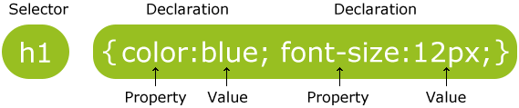

The selector points to the HTML element you want to style.

The declaration block contains one or more declarations separated by semicolons.

Each declaration includes a property name and a value, separated by a colon.

|  |  |
| --- | --- |
| **Properties** | **Values** |
| background-attachment | scroll, fixed |
| background-color | (color), transparent |
| background-image | none, (location) |
| background-position | (percent), (length), top, center, bottom, left, center, right |
| background-repeat | repeat, repeat-x, repeat-y, no-repeat |
| Background | Any of the above background values separated by spaces. |
| Color | (color) |

|  |  |
| --- | --- |
| **Properties** | **Values** |
| margin-bottom | (length), (percent), auto |
| margin-left | (length), (percent), auto |
| margin-right | (length), (percent), auto |
| margin-top | (length), (percent), auto |
| margin | Any of the above margin values in top, right, bottom, left order separated by spaces. |
| padding-bottom | (length), (percent) |
| padding-left | (length), (percent) |
| padding-right | (length), (percent) |
| padding-top | (length), (percent) |
| padding | Any of the above padding values in top, right, bottom, left order separated by spaces. |
| border-bottom-width | medium, thin, thick, (length) |
| border-bottom | Any of the border-top-bottom, border-color and border-style values. |
| border-color | (color) |
| border-left-width | medium, thin, thick, (length) |
| border-left | Any of the border-top-left, border-color and border-style values. |
| border-right-width | medium, thin, thick, (length) |
| border-right | Any of the border-right-width, border-color and border-style values. |
| border-style | none, dotted, dashed, solid, double, groove, ridge, inset, outset |
| border-top-width | medium, thin, thick, (length) |
| border-top | Any of the border-top-width, border-color and border-style values. |
| border | Any of the border values. Applies to all borders. |
| height | auto, (length), (percent) |
| width | auto, (length), (percent) |
| list-style-type | disc, circle, square, decimal, lower-roman, upper-roman, lower-alpha, upper-alpha, upper-latin, hebrew, armenian, georgian, cjk-ideographic, hiragana, katakana, hiragana-iroha, katakana-iroh, none |
| list-style-image | none, (url) |
| list-style-position | outside, inside |
| **Properties** | **Values** |
| list-style | Any of the above list-style values separated by spaces. |
| white-space | normal, pre, nowrap |
| border-collapse | collapse, separate, inherit |
| border-spacing | (length)(length), inherit |
| caption-side | top, bottom, left, right, inherit |
| empty-cells | show, hide, inherit |
| speak-header | once, always, inherit |
| table-layout | auto, fixed, inherit |

**Three Ways to Insert CSS**

There are three ways of inserting a style sheet:

* Internal style sheet
* Inline style
* External style sheet

**Internal Style Sheet**

An internal style sheet should be used when a single document has a unique style. You define internal styles in the head section of an HTML page, inside the <style> tag, like this:

<head>  
<style>  
hr {color: sienna;}  
p {margin-left: 20px;}  
body {background-image: url("images/background.gif");}   
</style>  
</head>

**Inline Styles**

An inline style loses many of the advantages of a style sheet (by mixing content with presentation). Use this method sparingly!

To use inline styles, add the style attribute to the relevant tag. The style attribute can contain any CSS property. The example shows how to change the color and the left margin of a paragraph:

<p style="color:sienna;margin-left:20px;">This is a paragraph.</p>

**A.5 Procedure/Task:**

**1. a) Use the embedded style, style the web page in the lab with**

**the following styles:**

a) h1 - color: blue; background -color: yellow

b)h1, h2, h3 - font family: "Trebuchet MS", "Lucida Grande", Tahoma, sansserif

c) body – font family: Georgia, Cambria, "Times New Roman", serif

**b) create a web page and Use the separate CSS file, style the web page with**

**the following styles**:

a)header, footer - color: white; background color: 213643;

b) h1, h2, h3 - font family: "Trebuchet MS", "Lucida Grande", Tahoma, sans-serif;

c)body – font family: Georgia, Cambria, "Times New Roman", serif;

d) make the text to red

e) Class first to color: 728B96; font style: italic;

**2. Demonstrate different types of position using box model**

3.

1. 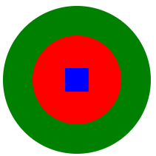
2. Create a web page as below

**

Prepare the document. Save and close the file and name it as **EXP05_Roll no_Batch no.**

**PART B**

(PART B: TO BE COMPLETED BY STUDENTS)

(Students must submit the soft copy as per following segments within two hours of the practical. The soft copy must be uploaded on the Blackboard or emailed to the concerned lab in charge faculties at the end of the practical in case the there is no Black board access available)

|  |  |
| --- | --- |
| Roll No. : C035 | Name: Sukhada Gulhane |
| Class : B | Batch : B2 |
| Date of Experiment : | Date/Time of Submission : |
| Grade : |  |

**B.1 Code:**

*(Paste your Code here)*

***Task 1.a***

<!DOCTYPE html>

<html lang="en">

<head>

    <meta charset="UTF-8">

    <meta name="viewport" content="width=device-width, initial-scale=1.0">

    <title>Task 1.a</title>

</head>

<style>

    h1 {

        color: blue;

        background-color: yellow;

    }

    h1, h2, h3 {

        font-family: "Trebuchet MS", "Lucida Grande", Tahoma, sans-serif;

    }

    body {

        font-family: Georgia, Cambria, "Times New Roman", serif;

    }

</style>

<body>

    <header>

        <h1>Hello this is task 1.a</h1>

    </header>

    <section>

        <h2>Hello this is task 1.a</h2>

        <h3>Hello this is task 1.a</h3>

    </section>

</body>

</html>

***Task 1.b***

<!DOCTYPE html>

<html lang="en">

<head>

    <meta charset="UTF-8">

    <meta name="viewport" content="width=device-width, initial-scale=1.0">

    <link rel="stylesheet" href="style.css">

    <title>Task 1.b</title>

</head>

<body>

    <header>

        <h1>Hello this is task 1.a</h1>

    </header>

    <section>

        <h2>Hello this is task 1.a</h2>

        <h3 class="first">Hello this is task 1.a</h3>

    </section>

    <footer>

        <p>This is foooter</p>

    </footer>

</body>

</html>

Style

header {

    color: white;

    background-color: #213643;

}

h1 , h2, h3 {

    font-family: "Trebuchet MS", "Lucida Grande", Tahoma, sans-serif;

}

body {

    font-family: Georgia, Cambria, "Times New Roman", serif;

}

* {

    color: red;

}

.first {

    color: #728B96;

font-style: italic;

}

***Task 2***

<!DOCTYPE html>

<html lang="en">

<head>

    <meta charset="UTF-8">

    <meta name="viewport" content="width=device-width, initial-scale=1.0">

    <link rel="stylesheet" href="style2.css">

    <title>Box Model with Different Positioning</title>

</head>

<body>

    <h1>CSS Box Model with Different Positioning</h1>

    <div class="box static">

        Static

    </div>

    <div class="box relative">

        Relative

    </div>

    <div class="box absolute">

        Absolute

    </div>

    <div class="box fixed">

        Fixed

    </div>

    <div class="box sticky">

        Sticky

    </div>

</body>

</html>

Style2

    .box {

        width: 150px;

        height: 150px;

        padding: 20px;

        margin: 10px;

        border: 5px solid black;

        background-color: lightblue;

        text-align: center;

    }

    .static {

        position: static;

    }

    .relative {

        position: relative;

        top: 30px;

        left: 30px;

    }

    .absolute {

        position: absolute;

        top: 100px;

        left: 100px;

    }

    .fixed {

        position: fixed;

        top: 20px;

        right: 20px;

    }

    .sticky {

        position: sticky;

        top: 50px;

        background-color: lightgreen;

    }

**B.2 Output**

*(Take screen shots of the output at run time and paste it here)*

***Task 1.a***

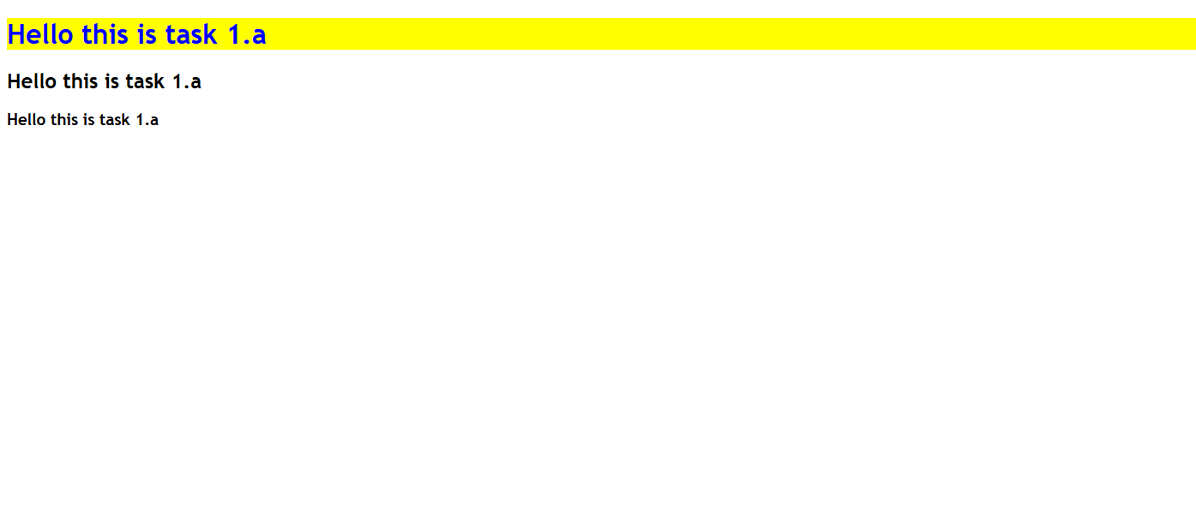

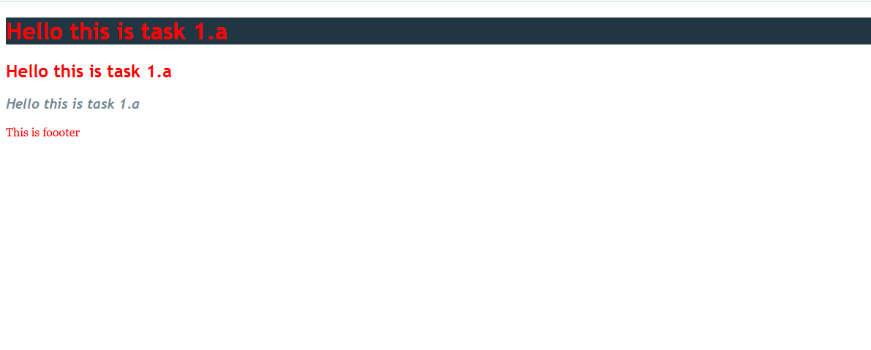

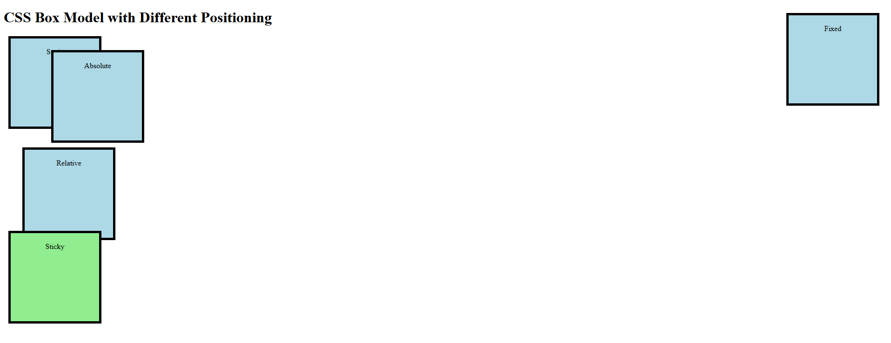

**B.3 Conclusion:**

*(Students must write the conclusion as per the attainment of individual outcome listed above)*

**B.3 Observations and Learning:**

*(Students must write their observations and learnings as per the attainment of individual outcome listed above)*

**B.4 Question of Curiosity**

*(To be answered by student based on the practical performed and learning/observations)*

Q1. What is CSS Style Rule? Explain with syntax.

Q2. Differentiate between ID and class selectors

Q3. List down all the text properties in CSS.

Q.4. Describe any 10 CSS3 tags apart from ones mentioned above that are used by you with syntax & example.

Reference

* [Background](https://www.w3resource.com/html-css-exercise/css-properties/background.php)
* How to set different background properties in one declaration?
* [Background Attachment](https://www.w3resource.com/html-css-exercise/css-properties/background-attachment.php)
* How to set the background-attachment property whether a background image is fixed or scrolls with the rest of the page?
* Background Color
* a. How to specify that the background color should be transparent?
* b. How to specify the animate background color?
* c. How to set color property to its default value?
* Background Image
* How to set a background-image for the body element?
* Background Image Original
* How to set the background image starts from the upper left corner of the padding edge
* b. How to set the background image starts from the upper left corner of the border?
* c. How to set the background image starts from the upper left corner of the content?
* d. How to sets this property to its default value?
* Background Position
* ow to set the a background-image in the right-center of a document?
* b. How to set the a background-image as horizontal and vertical position in percentage of a document?
* c. How to set the a background-image as default position of a document?
* d. How to set the a background-image as horizontal and vertical position in pixel of a document?
* Background Repeat
* a. How to set the background image will be repeated only vertically?
* b. How to set the background image will be repeated only horizontally?
* c. How the background-image will not be repeated?
* d. How to set repeat property to its default value?
* Background Size
* a. How to set the background image default value?
* b. How to set the width and height of the background image?
* c. How to sets the width and height of the background image in percent of the parent element?
* d. How to scale the background image to be as large as possible so that the background area is completely covered by the background image?
* e. How to scale the image to the largest size such that both its width and its height can fit inside the content area?
* f. How to sets this property to its initial value?

**Font:**

How to specify all the font properties in one declaration?

How to specify the font-size-adjust property?

How to make the text in all division elements wider?

How to set a paragraph to a small-caps font?

How to set different font weight for the paragraphs?

**Text**

How to set the text alignment for elements?

How to align the last line of a paragraph element to the right?

How to set the text decoration for heading elements?

How to set indent of the first line of all paragraph elements?

How to set justify property in the paragraph elements?

How to use text-overflow property?

How to add shadow to text?

How to change cases of text in paragraphs?